Eagle Audubon Society

Conservation Committee Report to the BOD February BOD Meeting
Daniel Roberts, Conservation Committee Chairman
February 11, 2025

Florida Legislature and State Planning Activities
Next month the Florida Legislature will be in session. Of particular interest to EAS during this time of year are the activities of state and local environmental groups and agencies and of course, the legislative committees. The Senate Natural Resource Committee and House of Representative counterparts are provided in the Appendix. In preparation for access to information and activities related to conservation that should be of interest to members of EAS, I prepared some information resources in this report. A list of news and current event sources related to Florida Conservation is provided in table 1.
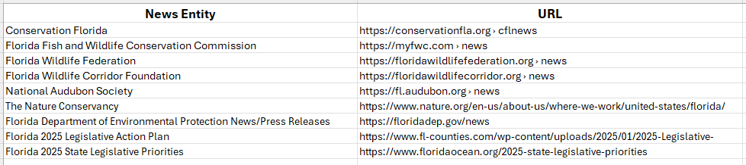Table 1. Important websites for current ecological and conservation news including legislative priorities.
A list of Florida state land purchase priorities is provided below in Table 2.
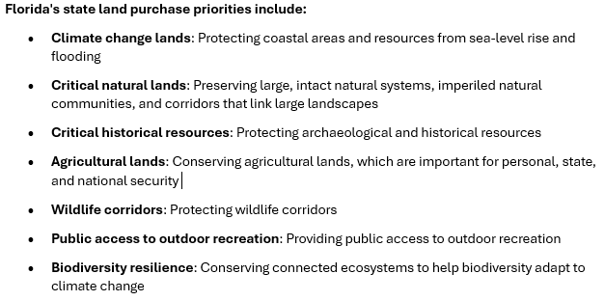

Table 2. General list of Florida state land purchase priorities relevant to the 2025 legislature.

Important Public Land Issues in our Region
- Crooked River Ranch Environmental Area The Conservation Foundation of the Gulf Coast recently helped to protect from development 64 acres along the Manatee River in Manatee County known as Crooked River Ranch – located halfway between I-75 and Fort Hamer Road in Parrish.
- Little Manatee Wild and Scenic River Act, which would designate 51 miles of the Little Manatee as part of the National Park Services Wild and Scenic River System.
- Skyway Fishing pier bird management has evolved with the help of several Audubon Chapters.
- Rattlesnake Key
- Florida Foreve statewide:
New Projects Added: Deer Creek Ranch, Floyd's Mound, Ford Marsh , Waccasassa Watershed, Welles Ranch, Williamson Cattle Company, Yarborough Ranch.
Projects Removed from the List: Arbuckle Creek Watershed, Charlotte Harbor Estuary, Horse Creek Ranch, River Property, South Walton County Ecosystem, Telogia Creek, Tiger Island/Little Tiger Island, Triple Diamond.
Other Issues not to be Forgotten
Florida Black Bear Hunting as a management strategy (letters were sent in January)
Withlacoochee Land Swap.
Regional RCC Meeting Held in Sefner
Florida Audubon Regional Conservation Committee meetings were held in late January. The Gulf Coast Regional Conservation Committee met in Sefner, FL. Steve Burkholder and Dan Roberts (and Sharon) attended. Representatives from several Audubon groups were represented and provided reports of their activities. Mary Keith, Tampa Audubon Society presided over the meeting and is generating a report that I will summarize for the EAS BOD next month. EAS and TAS shared the EAS files on the Skyway Bridge State Park activities related to seabird/fishing conflicts. There will be more to come on this meeting next month after receipt of the Chair report.
Florida State Parks
Related to the upcoming legislative session, the following workshop was sponsored by Florida Audubon and described in an email from Kristen Kosik, Florida Audubon Chapters Conservation Manager :
Audubon's Role in Florida State Park Planning: Wed. Feb 5th at 5pm ET
“With last fall's state park proposals for golf courses, motels and sport courts sent back to the drawing board at DEP (for now), Audubon chapters want to remain watchful for the return of these proposals or new ones. But what's the best way stay up to date and effectively influence the future of our parks? Join Audubon Florida's Julie Wraithmell for an overview of the state park planning process with some easy how-to's for your chapter to engage for your area's state parks. Chapter Presidents, Conservation Chairs, or other relevant chapter leaders are welcome to join us. Please no non-Audubon community partners--this will be a working strategy session as we co-create the best way to deploy Audubon's network.”
I attended the workshop. The agenda is presented in table 3. 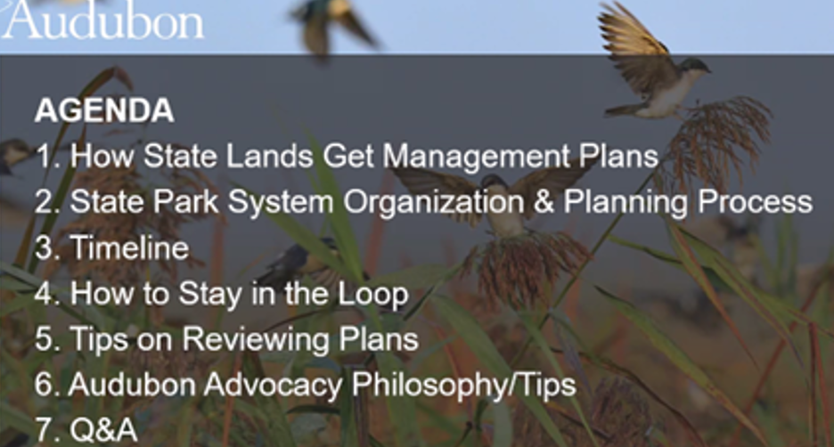
Table 3. Agenda for workshop on Audubon’s Role in Florda State Park Planning.
The workshop lasted a little over an hour and addressed all the items on the above agenda and a lot more. I preserved the slides and posted them in the following folder: EAS CONSERVATION . Topics covered in detail were steps in the general land procurement and management planning process, the new state park management planning process, a summary of all the state park districts, Audubon engagement opportunities including the Advocate Newsletter (figure 1).
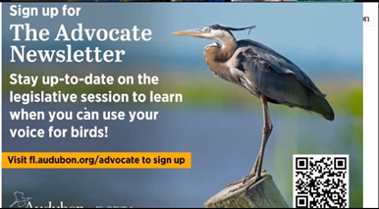
Figure 1. The Audubon Advocate Newsletter and website.
Kings Point Pond and Constructed Wetlands Activities Update
Members of the Conservation Committee have been involved in the Kings Point Pond projects. I have a lot of interest in constructed wetlands as mitigating aquatic habitats. I have been working with Rob Davies and Steve Ashton. The Kings Point ponds are around 40 years old and many need various levels of repair and maintenance. It is possible a budget development process to fund maintenance is being considered at Kings Point. Maintenance of these structures may provide an excellent opportunity to enhance the biological and overall ecological functionality of the ponds, enhance the management rules and improve the overall functional efficacy with regard to wildlife and fishery elements of the structures as well as their impact downstream for Cypress Creek and the Little Manatee River. The pond committee is collecting bathymetry data on each pond. I volunteered to augment this with GIS digitized features in order to accurately define shoreline length and pond surface area. These 2 added features allow volume calculation of individual structures as well as the ability to compute the overall volume of the constructed watershed. The data is complete for the first 9 ponds (table 4). Steve Ashton has requested another 9 ponds (Pond 4, Pond 5, Pond 7, Pond 8, Pond 11, Pond 13, Pond 15. Pond 16, and Pond 19). Those will be completed this week. The process consists of pond digitization by construction of 2 dimensional polygons mirroring the pond surface with subsequent analysis of the resulting imagery metrics using a Geographic Information Platform (GIScience, ArcGIS). An example of the resulting product is provided in figure 2. The first 9 pond metrics are found int table 4.

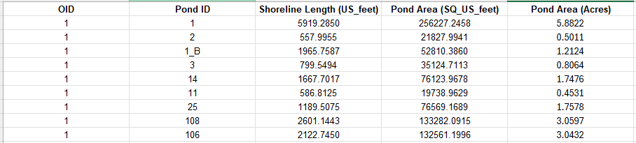
Table 4. Constructed pond metrics for selected wetland structures in Kings Point.

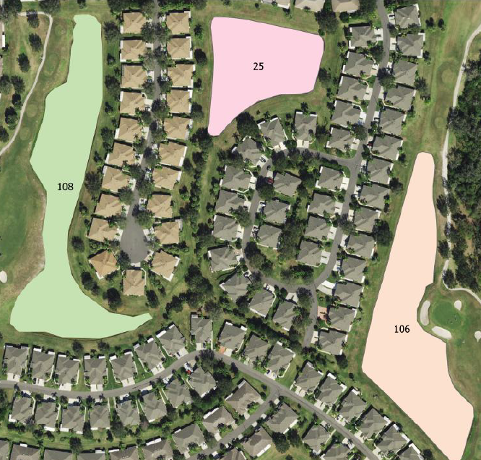
Figure 2. Digitized pond features (ponds 25, 106, and 108) using a GIS and digital orthoquad aerial imagery.
Finally, for this report, I am building a library of documents related to regional conservation issues and elements, largely included in these monthly EAS reports. Access to this information is provided to the BOD in the link above. Please do not distribute the link outside of EAS.

Appendix

2024-2026

Florida Senate Committee on Environment and Natural Resources

Members
Chair:
Senator Ana Maria Rodriguez (R)
Vice Chair:
Senator Blaise Ingoglia (R)
- Senator Kristen Aston Arrington (D)
- Senator Bryan Avila (R)
- Senator Jason Brodeur (R)
- Senator Nick DiCeglie (R)
- Senator Gayle Harrell (R)
- Senator Tina Scott Polsky (D)
- Senator Carlos Guillermo Smith (D)
The Florida House of Representatives has a Natural Resources & Disasters Subcommittee and an Agriculture & Natural Resources Budget Subcommittee.
Natural Resources & Disasters Subcommittee
- Chair: Adam Botana (R)
- Vice Chair: James Vernon "Jim" Mooney, Jr. (R)
- Democratic Ranking Member: Kelly Skidmore (D)
- Location: 303 House Office Building, 402 South Monroe Street, Tallahassee, FL 32399-1300
- Contact: (850) 717-4890
Agriculture & Natural Resources Budget Subcommittee
- Members: Jon Albert (R), Jose Alvarez (D), Webster Barnaby (R), Robin Bartleman (D), Yvette Benarroch (R), Dean Black (R), Yvonne Hayes Hinson (D), Debbie Mayfield (R), Jim Mooney, Jr. (R), Susan Plasencia (R), Michelle Salzman (R), and Meg Weinberger (R)

